Denver's Next Great Development Opportunity May Not Be Another Stadium
It may be the hospitality infrastructure that connects them.
Denver's Emerging Sports & Hospitality Corridor
Professional sports venues are changing, as they are no longer viewed simply as places to host games. Across the nation professional sports venues have evolved as catalysts for mixed-use development, neighborhood revitalization, and hospitality investment. In addition to considering how many seats a stadium offers, LW Hospitality Advisors (LWHA) and Lodging Analytics Research & Consulting (LARC) analyzes whether a surrounding development creates sufficient year-round demand to support lodging facilities which is where long-term value is created.
Professional sports ownership groups now realize the potential of these developments extends beyond a stadium itself, and are therefore also investing in hotels, restaurants, entertainment districts, residential neighborhoods, and public gathering places. Projects involving the Atlanta Braves, Los Angeles Rams and Charges, the Buffalo Sabres, and the Dallas Cowboys along with numerous other teams and locales reflect similar trends. Furthermore, developments are being evaluated in numerous other markets including Chicago, San Antonio, Salt Lake City, Nashville, and Cleveland. Given the historical precedent of public stadium financing, modern sports real estate trends focus on civic engagement, whether through significant privately funded neighborhood infrastructure or public-private integration that drives year-round local tax revenue.
Considering what is currently occurring in Denver, we do not see five unrelated projects, however, perceive an opportunity to create a connected sports, entertainment, and hospitality corridor. Coors Field, Ball Arena, The River Mile, Burnham Yard, and the future home of Denver Summit FC can complement one another through light rail, walkability, bike connections, and mixed-use development. Instead of functioning as separate destinations, they have the potential to become a connected visitor experience that is currently underserved by the hospitality sector.
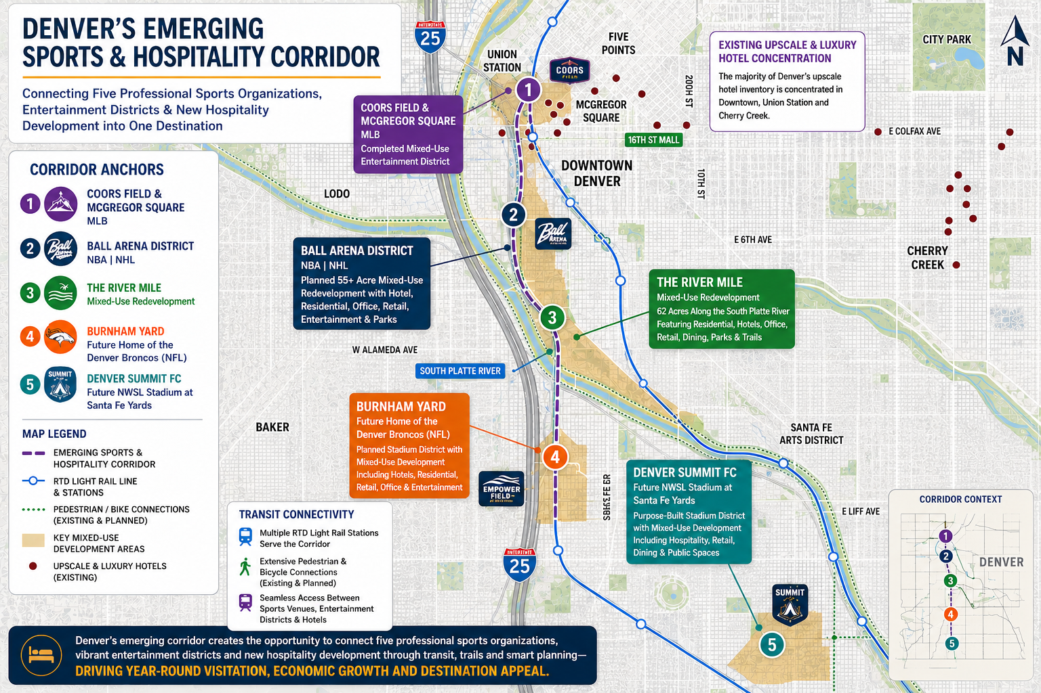
The success of McGregor Square has demonstrated what is possible. Anchored by The Rally Hotel, restaurants, entertainment, office space, residential uses, and year-round programming, the development has transformed the area around Coors Field from primarily a game-day destination into an active neighborhood. Just to the southwest, Kroenke Sports & Entertainment is proposing one of the largest redevelopment projects in Denver's history. More than 55 acres surrounding Ball Arena could become a walkable neighborhood with housing, restaurants, retail, office space, entertainment, public parks, and a full-service hotel. Denver planners have described the redevelopment as transformational, comparing its potential impact to what Coors Field did for Lower Downtown.
The River Mile continues that vision along the South Platte River with plans for hotels, housing, restaurants, office space, parks, trails, and public gathering places. Burnham Yard is set to become the future home of the Broncos while creating another mixed-use district anchored by hospitality and entertainment and is expected to be a major economic catalyst for this former industrial area. Anchoring the southern end of the corridor is the future home of Denver Summit FC and its purpose-built stadium district at Santa Fe Yards. The project reflects the continued growth of professional women's sports while adding another year-round anchor for hospitality, entertainment, and mixed-use development. Together with the other planned projects, it broadens the corridor's event calendar and creates additional demand for hotels, restaurants, and businesses.
It is worth considering these developments not only individually, but as part of an integrated corridor. A visitor could check into a hotel near Ball Arena on Friday afternoon, attend an Avalanche or Nuggets game that evening, spend Saturday exploring The River Mile before riding an e-bike or scooter to a Denver Summit FC match that night, and then take light rail to a Broncos game on Sunday afternoon. Throughout the weekend, that visitor could enjoy restaurants, entertainment, and public spaces across the district. Few cities have the ability to create this kind of connected, multi-day visitor experience. From a hospitality perspective, these experiences help turn day trips into weekend getaways, generating additional hotel nights and broader economic benefits for the city.
From a hospitality perspective, diversity matters. Baseball, football, basketball, hockey, professional women's soccer, concerts, and community programming all contribute to demand. More event days create more overnight stays which invariably results in consumer spending that benefits restaurants, retailers, attractions, transportation providers, and the local economy. Sports tourism is a significant economic driver, and overnight visitation is at the heart of its impact. Concentrating multiple professional sports venues within a connected district creates the opportunity for hotel demand to compress during overlapping events while also diversifying visitation throughout the year. With different leagues playing in different seasons, the corridor is less dependent on any single team or event, reducing seasonality and creating a more stable base of lodging demand.
A review of CoStar hotel performance data for the twelve months ending May 2026, indicates nine upscale, upper upscale, and luxury hotels serving Coors Field, Ball Arena, and Empower Field having achieved 72% occupancy, $244 Average Daily Rate (ADR), and resultant Revenue Per Available Room (RevPAR) of $175. A broader competitive set of twenty comparable downtown hotels within the same brand scale averaged 67.8% occupancy, a $217 ADR, and RevPAR of $147, or a 19% RevPAR premium which is interesting considering that differential exists before much of the proposed corridor has been built and despite relatively limited hotel inventory immediately surrounding Ball Arena and Empower Field.
The accompanying map reinforces the point. Most upscale hotels remain concentrated around Downtown, Union Station, and Cherry Creek, leaving much of the emerging corridor underserved by hospitality, which is a substantial opportunity. Professional sports create visitation which allow lodging facilities to accommodate overnight guests which in turn enhances opportunities to host group meetings, events, visiting teams, media, sponsors, and corporate partners.
While each project may not proceed exactly as it is currently envisioned, if enough comes to fruition an opportunity to connect them and yield greater total output. Denver already has the foundation to add strategic hospitality investment to world-class sports venues, transit, and mixed-use development, and create one of the country's most compelling sports and hospitality destinations. Visitors may come for a game, but they'll have plenty of reasons to stay for the weekend, which is a real opportunity.

Sources
This article is based on publicly available planning documents and project materials from Kroenke Sports & Entertainment (Ball Arena Vision Plan), The River Mile, McGregor Square, and the City and County of Denver, together with independent hotel market analysis by the author using CoStar hotel performance data, as well as LWHA and LARC’s proprietary databases. Additional background information was drawn from reporting by The Denver Post, Denver Business Journal, BusinessDen, Axios Denver, and The Denver Gazette.
About the Author
Brett Russell is Managing Director – Denver for LW Hospitality Advisors, the nation's leading hospitality consulting and valuation firm. With more than 25 years of experience in hospitality and commercial real estate consulting, Mr. Russel specializes in hotel and mixed-use destination development feasibility studies, market analyses, and appraisals and has advised on numerous hospitality and entertainment district projects associated with collegiate and professional sports venues throughout the United States.

